Lab test-4
Ht.No: 2403A54037
Name: Ramakrishna Vemula

Question-1: (API Integration)
a) Integrate payment verification using a RazorPay or Stripe API.
Prompt:
"Generate Python Flask code to integrate RazorPay (or Stripe) payment verification. The code must verify payment status using API keys, fetch payment details from the API, and return success/failure response.

Code:
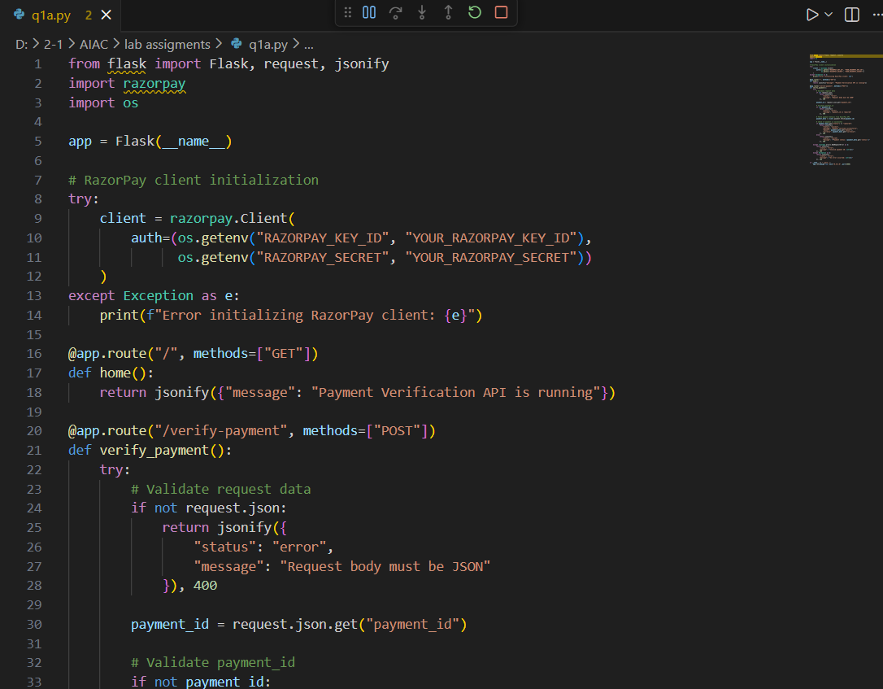
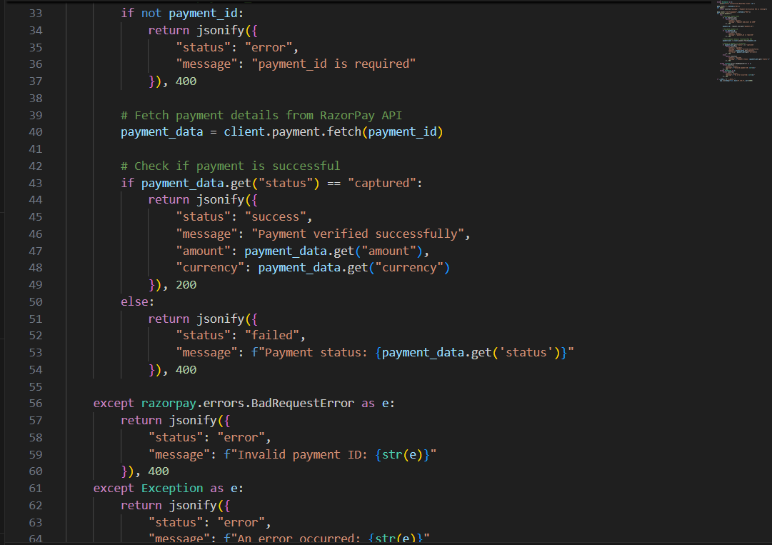
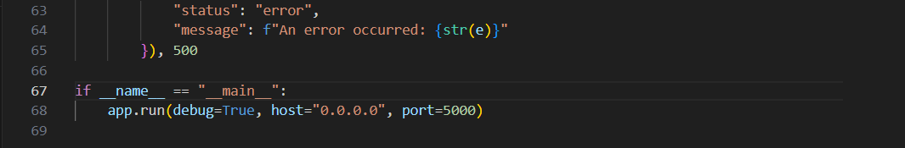

Output: 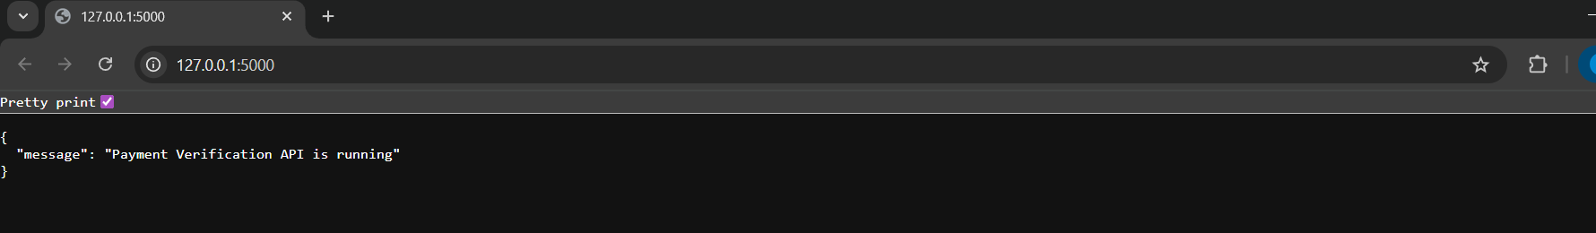

Observation:
1. API requires valid Key ID and Secret for authentication.
2. Payment details are fetched in JSON format using the payment ID.
3. Status “captured” confirms successful payment.
4. HTTPS ensures secure data transfer.
5. Correct credentials and stable network are required for proper API response.
b) Add exception handling for transaction failures.
Prompt:
Write Python Flask code that adds exception handling for API errors during payment verification, such as invalid payment ID, network issues, or failed transaction status.
Code: 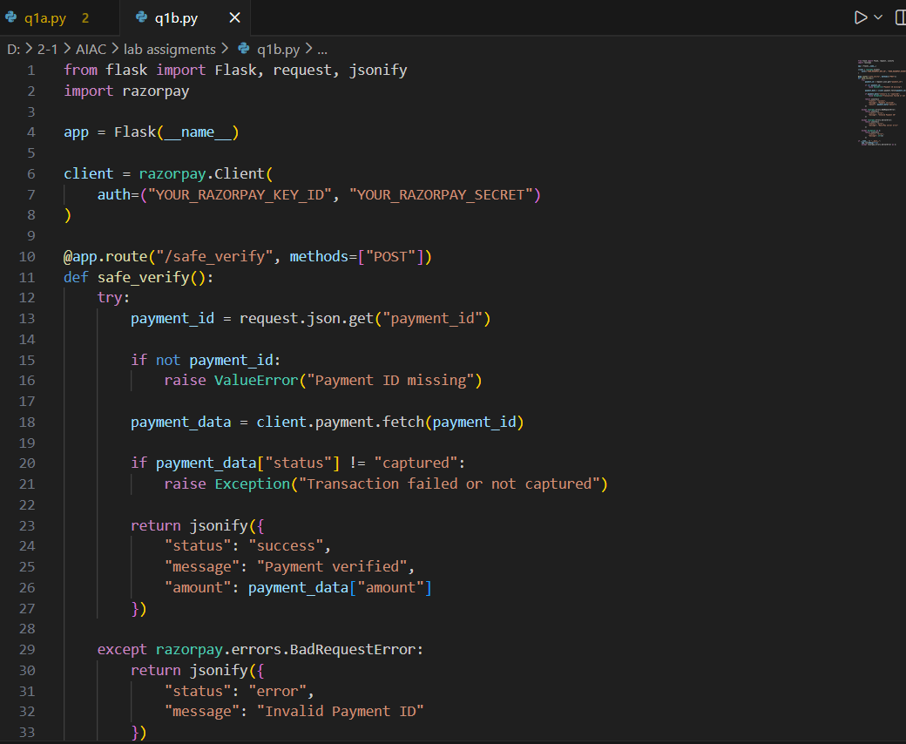
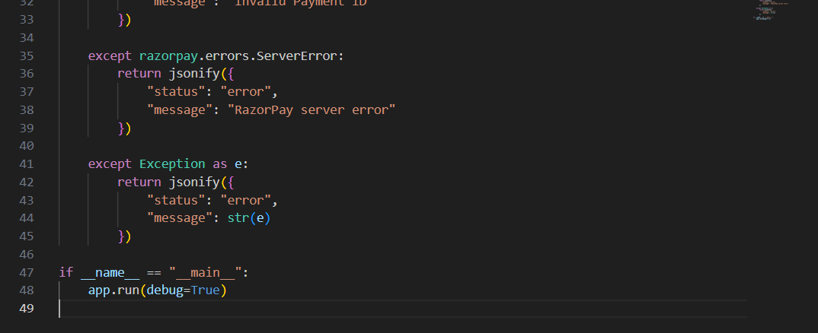
Output:
Observation:
1. Exception handling prevents app crashes during payment verification.
2. Invalid payment IDs and server errors are detected using try-except blocks.
3. Custom errors are shown when a transaction is not captured.
4. User gets clear JSON error messages instead of system errors.
5. Error handling increases reliability and stability of the API module.

Question-2: (Code Translation)
a) Convert a JavaScript async function into Python using AI coding tools
Prompt:
Convert the following JavaScript async function into an equivalent Python function using async/await. Ensure the logic, delay, and asynchronous behavior are preserved
Code: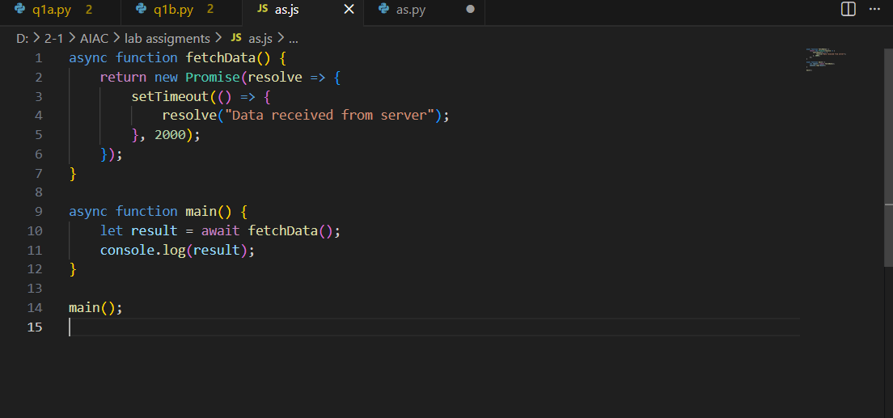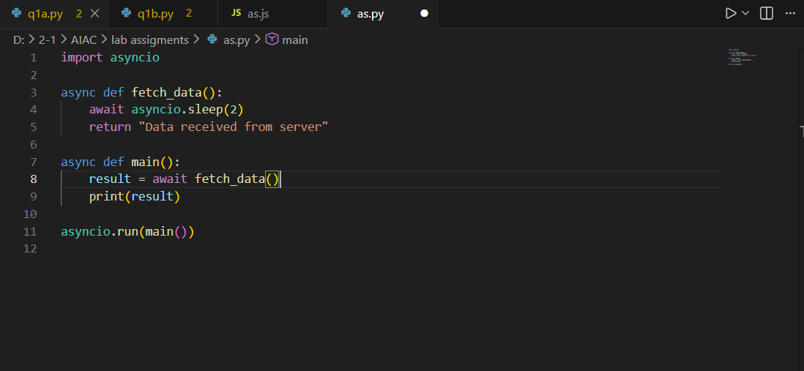

Output:

Observation:
- JavaScript uses setTimeout() to create an asynchronous delay.
- Python uses asyncio.sleep() for non-blocking delay.
- async and await work similarly in both languages to pause execution until data is returned.
- Both functions return the same result but use different runtime models:
- JavaScript uses Event Loop (V8 engine)
- Python uses Asyncio event loop

b) Compare the asynchronous behavior between both languages
prompt:
“Explain the difference in asynchronous behavior between JavaScript (Node.js) and Python (asyncio), focusing on event loops, thread usage, and execution flow."

Comparison Table (Async Behavior):

Feature | JavaScript (Async/Await) | Python (Asyncio)
Execution Model | Single-threaded event | Coroutine-based event
Concurrency Type | Non-blocking I/O only | Non-blocking I/O + cooperative multitasking
Keywords | async, await | async, await
Delay Mechanism | setTimeout(), Promises | asyncio.sleep(), coroutines
Threading | No multithreading y default | Can integrate with threads
Runtime | V8 Engine (Node.js) | CPython Asyncio Event Loop

Observation:
- JavaScript is completely single-threaded and fully relies on its event loop and Promises.
- Python uses cooperative multitasking with coroutines, offering more control through asyncio.
- In both languages, async/await is syntactically similar but the internal execution model differs.
- JavaScript is optimized for web servers, while Python async is optimized for I/O-bound tasks and APIs.

